Chapter 7, Solution 34.

(a) 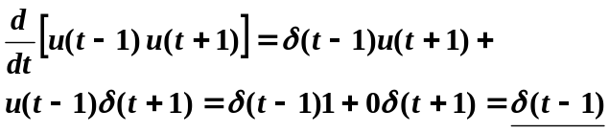
(b) 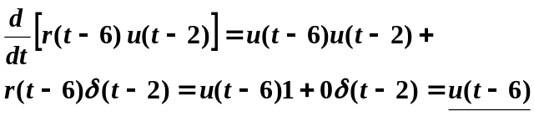

(c) 